
CONFIDENTIAL CS/NOV 2026/ICT450

UNIVERSITI TEKNOLOGI MARA FINAL EXAMINATION

COURSE
COURSE CODE
EXAMINATION TIME
DATABASE DESIGN AND DEVELOPMENT

ICT450
NOVEMBER 2026
3 HOURS

INSTRUCTIONS TO CANDIDATES

- This question paper consists of five (5) questions.

- Answer ALL questions in the Answer Booklet. Start each answer on a new page.

- Do not bring any material into the examination room unless permission is given by the invigilator .
- Please check to make sure that this examination pack consists of: i) the Question Paper
  - an Answer Booklet - provided by the Faculty

- Answer ALL questions in English.

DO NOT TURN THIS PAGE UNTIL YOU ARE TOLD TO DO SO

This examination paper consists of 6 printed pages.

QUESTION 1 (20 marks)
a) Figure 1.0 shows a traditional file system which has many separate and unrelated files.
i) Discuss TWO (2) problems that might arise because of traditional file system as shown in Figure 1.0.
(4 marks)
ii) Problems inherent in file systems cause a need to implement a database system. Redesign the system in Figure 1.0 using database approach.
(4 marks)
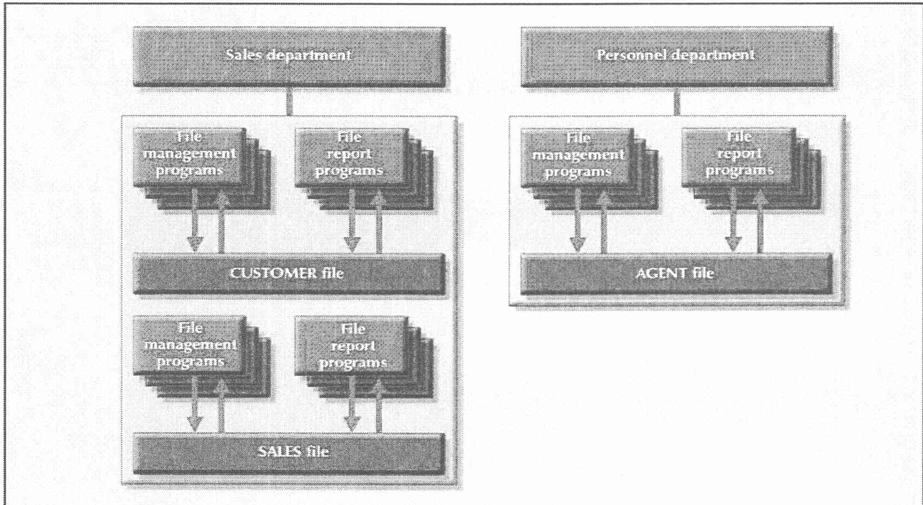
Figure 1.0 : A simple file system
b) Briefly describe TWO (2) characteristics of mobile database and give TWO (2) examples of appropriate mobile database applications that you would recommend to Student Representative Council of UiTM. Give ONE (1) reason why you need those application.
(8 marks)
c) Given the following relational schema :
COURSE (CourseCode, CourseName)
SUBJECT (SubjectCode, SubjectName, TeacherCode)
TEACHER (TeacherCode, FName, LName, DeptCode)
COURSE_SUBJECT (CourseCode, SubjectCode, SubjectType)
i) Identify the primary key for each table
(2 marks)
ii) Briefly explain ONE (1) purpose of having primary key in database.
(2 marks)
QUESTION 2 (20 marks)
a) Database Design phase is the second phase of the Database Life Cycle (DBLC) that focuses on the design of the database model. It consists of three essential stages which are conceptual design, logical design and physical design. Briefly explain the differences among these stages and identify either they are software-dependent or not.
(8 marks)
b) Describe the FOUR (4) characteristic of big data. Give an example for each characteristics.
(8 marks)
c) Spreadsheet application such as Microsoft Excel (shown in Figure 1) can also be used to store data. However, spreadsheet application cannot be considered as a database system because there are several basic database functions that a spreadsheet cannot perform. Explain TWO (2) features of spreadsheet application that are different from database system.
(4 marks)
Table 3: STAFF table
STAFF_ID | STAFF_NAME | COURSE_ID
101 | Ronaldo | 10
102 | Vardy | 30
103 | Toney | 60
104 | Jimenez | 20
105 | Kane | 40
106 | Lukaku | 50
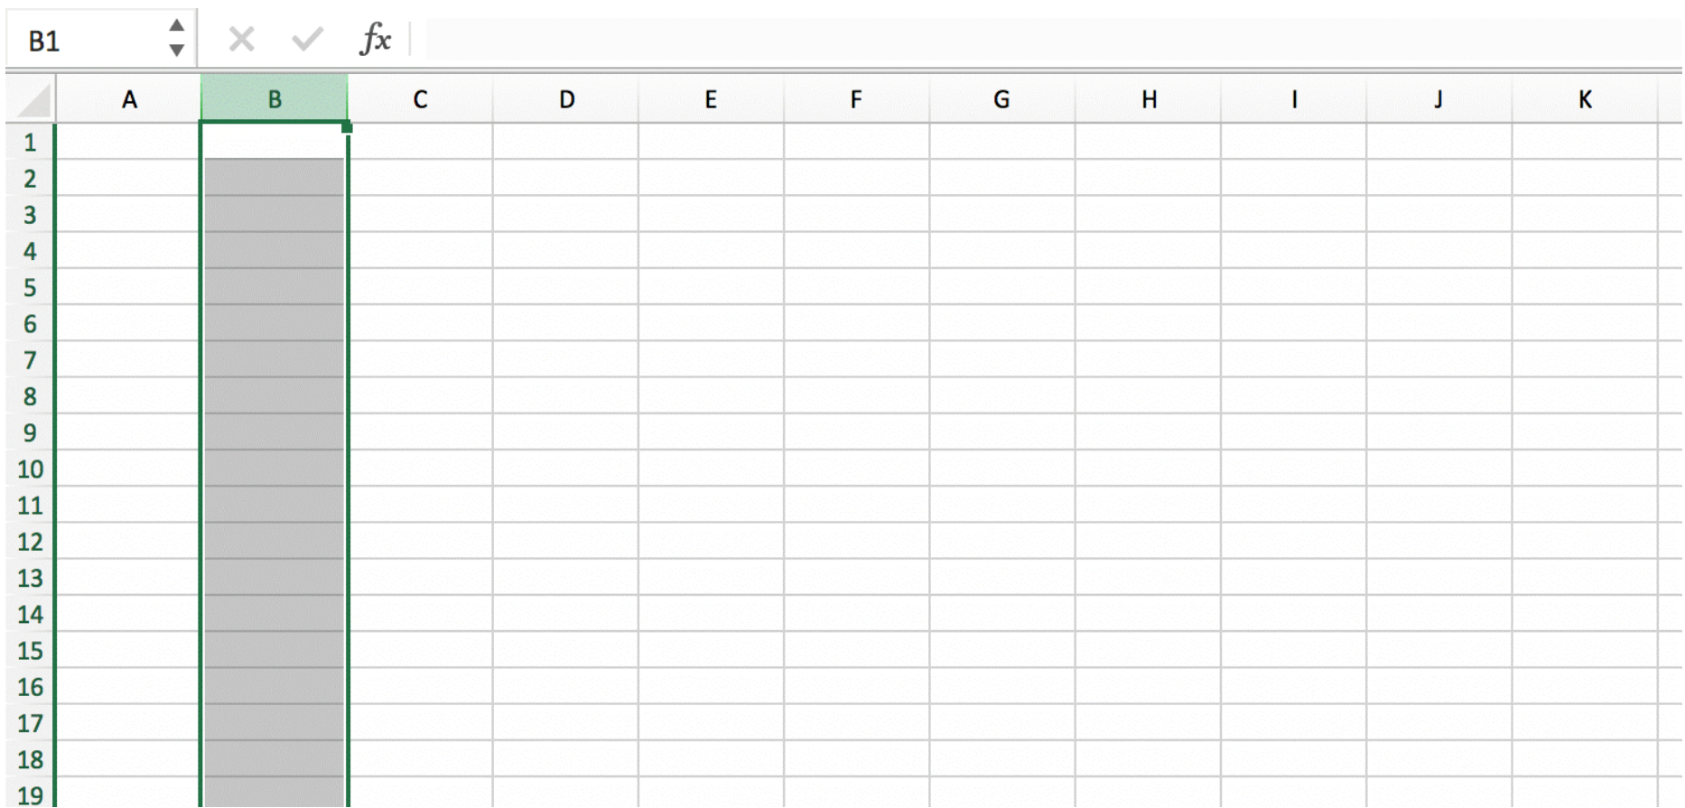
Figure 1: Spreadsheet Application
QUESTION 3 (20 marks)
Figure 1 shows the boarding pass for domestic flight in Malaysia. One customer can visit to many destinations and each destination can be visited by many customers.
The structure of boarding is given as the following relational schema.
BOARDING (CustIC, CustFirstName, CustLastName, {FlightID, PlaneType, Capacity, DestinationID, DestinationName}, DateDepart, DateArrive, TimeDepart, TimeArrive, Seat)
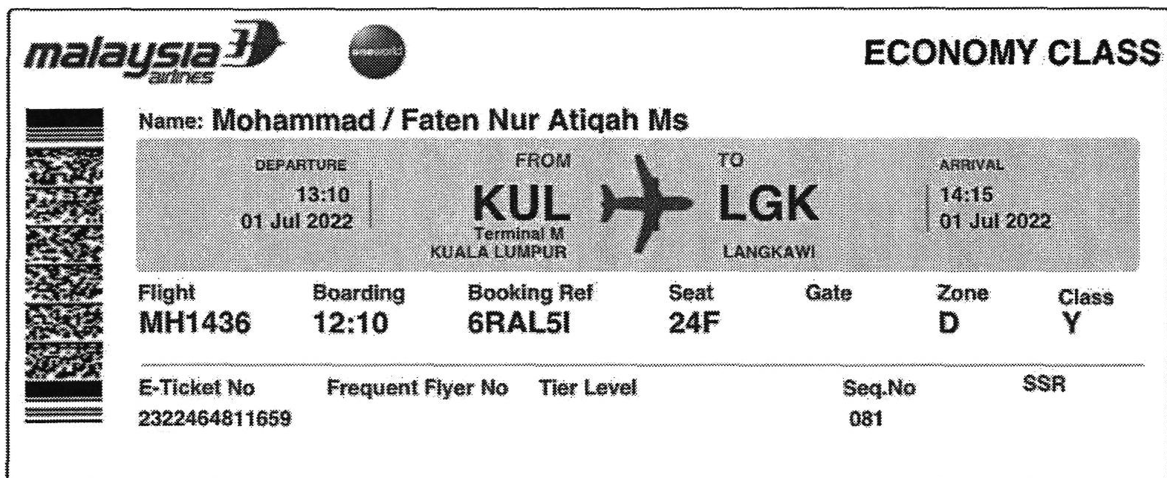
Figure 1 : Boarding Pass
a) Define normalization and describe the importance of having normalization in database design.
(3 marks)
b) Describe THREE (3) requirements for good normalized set of tables. Give an example for each requirements.
(6 marks)
c) Show all the steps to normalize the structure until third normal form (3NF). The primary key(s), partial dependencies and/or transitive dependencies need to be clearly identified.
(11 marks)
QUESTION 4 (20 marks)
The relation schema below shows the loan database system.
DEPARTMENT | (DeptID, DeptName)
APPLYLOAN | (ClientNum, LoanID, LoanTotal, LoanRemainder, LoanDate)
LOAN | (LoanID, LoanType, StaffID)
CLIENT | (ClientNum, ClientName, ClientAddress, ClientPhoneNum)
OFFICER | (StaffID, StaffName, DeptID)
Write SQL statements based on the following requirements.
a) Create the APPLYLOAN table.
(4 marks)
b) By using subquery, produce a list of client's names that makes a personal loan.
(4 marks)
c) Generate the total loan from year 2021 until 2023.
(4 marks)
d) List the names of officer who manage the housing loan and they are from finance department.
(4 marks)
e) Generate the total loan for each loan type.
(4 marks)
QUESTION 5 (20 marks)
One public university in Arau, Perlis is planning to develop an auxiliary police database system for a better coordination and reporting of summons and security duties. As a database designer, you are tasked to design the database system according to the following requirements:
- Details of each police officer such as their Police ID, name, position and email address.
- Each police officer has been assigned to five main duties. For safety reasons, each duty will be carried out by more than one police officer. The date and time of each assigned duty need to be recorded in the system.
- Each police officer also can issue summons to several students. The date summon issuance need to be recorded by the police officer.
- A summon will be issued if a student violates any rules and regulations.
- Each summon will consist more than one offense. Offense ID, offense name, description, and rate of fees need to be recorded in the system.
Based on the given information:
a) Construct a complete Entity Relationship Diagram (ERD) with all of the required tables, attributes, and relationships using the Crow's Foot notation that reflects all of the given business rules.
(16 marks)
b) Identify TWO (2) relevant information that you can get from the ERD you constructed in (a).
(4 marks)

